EAS JAVASCRIPT JQUERRY API DOCUMENT

# Message

## Installation

To use message import js file “loading.js”

Requirement library: Jquerry, Bootstrap

## Function

### $.message.error(message[,options])

* Use it to show message box with style error
* Parameters :

message: content of message type of text or html , **require**

options:

options.title

options.css

* Example: $.message.error(“This is error message!”);

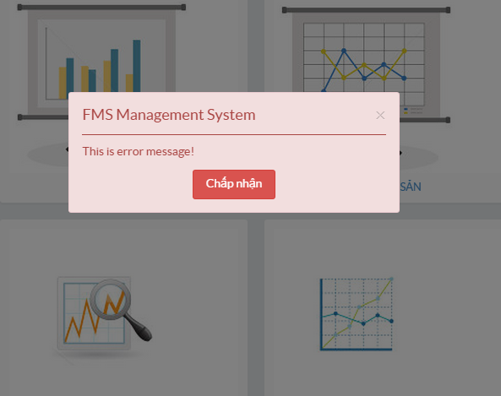

### $.message.warning(message[,options])

* Use it to show message box with style warning
* Parameters :

message: content of message type of text or html , **require**

options:

options.title

options.css

* Example: $.message. warning (“This is warning message!”);”);

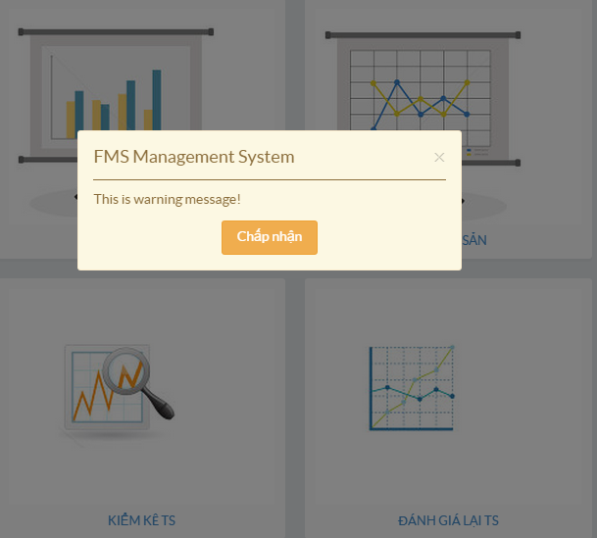

### $.message.success(message[,options])

* Use it to show message box with style success
* Parameters :

message: content of message type of text or html , **require**

options:

options.title

options.css

* Example: $.message. success (“This is success message!”);”);

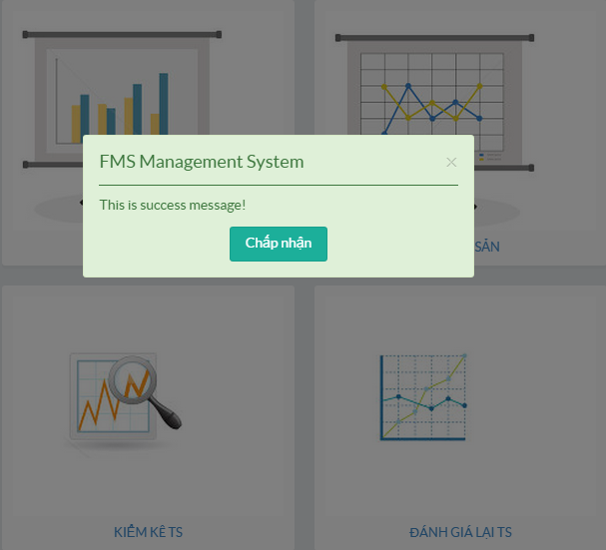

### $.message.confirm(message[,options])

* Use it to show message box with style confirm
* Parameters :

message: content of message type of text or html , **require**

options:

options.title

options.css

* LISTENER

'message.close': handle on message box closed

'message.confirm' handle on confirm button click

* Example:

message = $.message. confirm (“This is confirm message!”);”);

message.on('message.close',**function**(){

alert(‘closed’);

});

message.on('message.confirm',**function**(){

alert(‘confirm’);

});

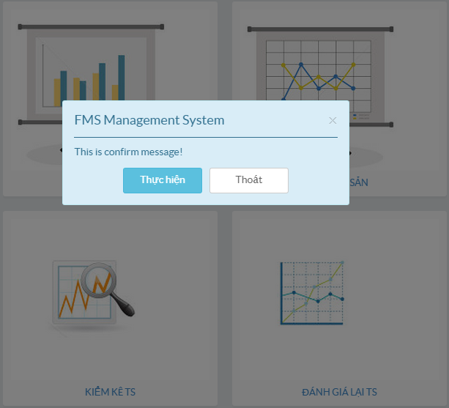

### $.message.notification(message[,postion][,options])

### $.message.init(message[,options])

### $.message.destroy()

## LISTENER

### message. close

### message.confirm

# Loading

# API

# PRINT